David Houston  
EE 225  
Bruce Barnes

State Variables

# Abstract

This lab focused on the basic properties of state variables and using them to solve high order circuits. In order to find a mathematically sounds solution to the problem we utilized MATLAB’s differential equation solver in order to use state variable analysis on the system. The solution MATLAB output was what we had expected and thusly confirmed our hypothesis on whether or not MALAB would perform the desired task.

# Introduction

Being a lab that consists of mostly programing, our main tool is MATLAB. Based on this projection, our calculations were first done by hand and then applied to the expertise that MATLAB has to offer.

# Procedure

It was first observed to solve the following circuit based on premise that we would be analyzing it for its state variables.

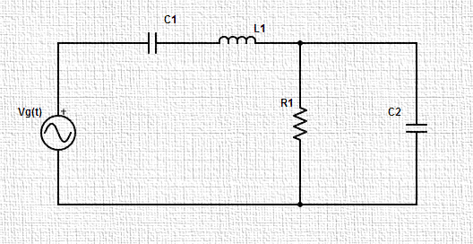

Based on our analysis we produced that following state variable equation with the initial condition matrix:

$$\left[\begin{matrix}{\dot{x}}_{1} \\ {\dot{x}}_{2} \\ {\dot{x}}_{3}\end{matrix}\right]=\left[\begin{matrix}0 & \frac{1}{C_{1}} & 0 \\ -\frac{1}{L} & 0 & -\frac{1}{L} \\ 0 & \frac{1}{C_{2}} & -\frac{1}{RC_{2}}\end{matrix}\right]\left[\begin{matrix}x_{1} \\ x_{2} \\ x_{3}\end{matrix}\right]+\left[\begin{matrix}0 \\ 1/L \\ 0\end{matrix}\right]v_{g}$$

$$x_{0}=\left[\begin{matrix}-1 \\ 0 \\ 0\end{matrix}\right]$$

For here we created a function names **ckt** in MATLAB so as to utilize the ode45 operation. This was then ran through a script file which executed the ode45 command and solved the state variables of the system producing the following graph.

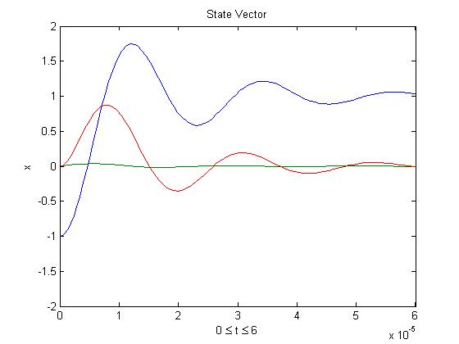

See Appendix A for MATLAB code

After this procedure we went about constructing a similar model for the following circuit and derived its corresponding state variable equations.

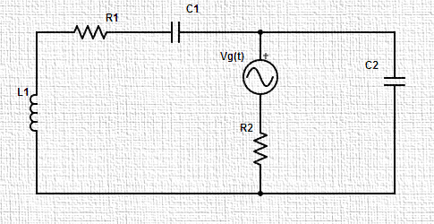

$$\left[\begin{matrix}{\dot{x}}_{1} \\ {\dot{x}}_{2} \\ {\dot{x}}_{3}\end{matrix}\right]=\left[\begin{matrix}-\frac{R_{1}}{L} & -\frac{1}{L} & \frac{1}{L} \\ \frac{1}{C_{1}} & 0 & 0 \\ -\frac{1}{C_{2}} & 0 & \frac{1}{R_{2}C_{2}}\end{matrix}\right]\left[\begin{matrix}x_{1} \\ x_{2} \\ x_{3}\end{matrix}\right]+\left[\begin{matrix}0 \\ 0 \\ -\frac{1}{C_{2}R_{2}}\end{matrix}\right]v_{g}$$

$$y\left(t\right)=\left[\begin{matrix}0 & 0 & -1\end{matrix}\right]\left[\begin{matrix}x_{1} \\ x_{2} \\ x_{3}\end{matrix}\right]+v_{g}$$

See Appendix B for mathematical computations

Once again we constructed a function named **ckt1** in MATLAB so as to utilize the ode45 feature. From that we wrote another script file to execute the command and from there produce the following functional graph.

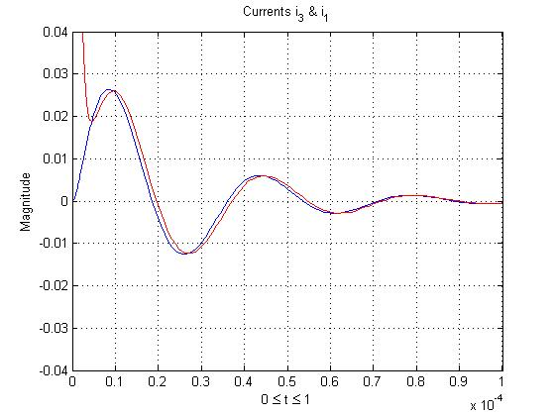

See Appendix A for MATLAB code

In order to check and see if MATLAB was correctly solving the system of state variables correctly we constructed our own solution based off of the state variables. After computing the state functions we used MATLAB’s matrix solving abilities and found the value of Y(s) (and therefore i3) and X1(s) below:

$$Y\left(s\right)=\frac{-s^{3}- 6.667e04 s^{2}- 5e10 s - 36}{s(s^{3}+ 1.067e06 s^{2}+ 1.167e11 s + 3.333e16)}$$

$$X_{1}\left(s\right)=\frac{3.333e09 s + 0.7738}{s^{3}+ 1.067e06 s^{2}+ 1.167e11 s + 3.333e16}$$

See Appendix B for mathematical computations

The step response of these function was found to be the graph shown below. While these graphs match the graphs above in shape, a factor of 2 had to be accounted for in the magnitudes. This fixed the problem, however, it is not clearly exactly where this problem originated at.

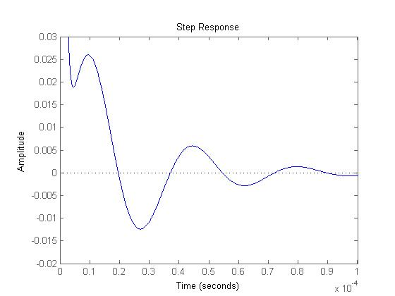

Temporal Step Response of I3

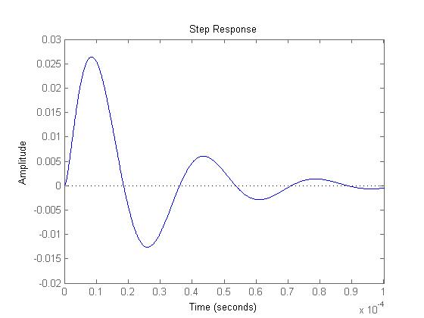

Temporal Step Response of X1

# Conclusion

After successfully analyzing the circuits in this lab we have come to realization that state variable analysis can have its pros and cons. When analyzing a system, utilizing the features of MATLAB, it becomes quite easy when approaching it from the state variable analysis. However, in some cases, like this one, it is much better to go with MATLAB than to try to do it by hand and get an answer as such. While our solutions were close in nature, it seemed as those there was a something taken into account by MATLAB that we did not foresee. This gave us the distortion factor of the magnitude by two. However, all in all MATLAB proved to be an invaluable tool for solving systems with state variables.

# Appendix A

%% *State Variables*

%% Part I

clear all

format SHORTE

t0=0; tf=60e-6;

tspan = [t0,tf];

x0 = [-1 0 0];

[t,x] = ode45('ckt',tspan,x0);

plot(t,x)

xlabel('0 \leq t \leq 6')

ylabel('x')

title('State Vector')

axis([0 6e-5 -2 2])

%% Part II

clear all

format SHORTE

t0=0; tf=1e-4;

tspan = [t0,tf];

x0 = [0; -1; -1];

[t,x] = ode45('ckt1',tspan,x0);

i3 = -(x(:,3)-1)/(5);

plot(t,x(:,1))

hold on

plot(t,i3,'r-')

xlabel('0 \leq t \leq 6')

ylabel('x')

title('State Vector')

axis([0 1e-4 -.04 .04])

%% Part III

format SHORTE

hold off

clear all

s = tf('s');

R1 = 20;

R2 = 5;

L = 300e-6;

C1 = 100e-9;

C2 = 200e-9;

A = [-R1/L -1/L 1/L; 1/C1 0 0; -1/C2 0 -1/(C2*R2)];

B = [0; 0; 1/(C2*R2)];

C = [0 0 1];

D = -1;

%Z_s = 1/s

I = eye(3);

X_s = (inv(s*I - A))*B

Y_s = (C*X_s + D)

i3 = (-Y_s)/(R2);

step(2*i3)

step(2*X_s(1))

axis([0 .0001 -.02 .03])

%--------------------------------------------

function xdot = ckt(t,x)

%This function utilizes the xdot function to solve

systems in state space

vg = 1;

C1 = 100e-9;

C2 = C1;

R = 30;

L = 184e-6;

xdot(1) = x(2)/C1;

xdot(2) = -(x(1) + x(3))/L + vg/L;

xdot(3) = x(2)/C2 - x(3)/(R*C2);

xdot = [xdot(1); xdot(2); xdot(3)];

end

%--------------------------------------------

function xdot = ckt1( t,x )

%This function utilizes the xdot function to solve

systems in state space

vg = 1;

C1 = 100e-9;

C2 = 200e-9;

R1 = 20;

R2 = 5;

L = 300e-6;

xdot(1) = ( (x(3)-x(2))/L ) - ( x(1)*R1/L );

xdot(2) = x(1)/C1;

xdot(3) = (-x(1)/C2) + ((vg-x(3))/(R2*C2));

xdot = [xdot(1); xdot(2); xdot(3)];

end

# Appendix B